**Leader Overview**



**Volume Overview**

**Get Going**

*The gift of the Holy Spirit was sent so that we might have power—power to go and make disciples. Some go to the farthest corners of the globe. Some only cross the street in front of their house. Still, God’s people always go. They go to work, school, grocery stores, kids’ soccer games, and family reunions. And wherever they go, they take their witness of Jesus with them. True believers live going and carrying out His mission.*

**Session Overview**

**Let Go**

*In this* **Live** *session, kids will discover how Jesus called some of His closest disciples to follow Him. They’ll learn about how the disciples were willing to leave things behind to follow Jesus. We can learn from the disciples’ example and choose to always put Jesus’ mission above our preferences or circumstances. Kids will learn that they can make a difference right now. They don’t need to wait until they’re older to follow Jesus and be part of His mission.*

**Bible Lesson**

The First Disciples Leave Everything

[Luke 5:1–11](https://ref.ly/logosref/Bible.Lk5.1-11)

**Faith Fact**

I can make a difference.

**Faith Verse**

[John 20:21](https://ref.ly/logosref/Bible.Jn20.21) (NLT)

[Jesus] said, “Peace be with you. As the Father has sent me, so I am sending you.”

**Preparing for the Session**

**Leader Preparation Time: 20–25 Minutes**

|  |
| --- |
| ***You Will Need***  ***Large Group***  *• Bible*  *• Worship songs (Song suggestions: “Zeal” (Lyric Video) by The Belonging Co; “To the Ends of the Earth” by Hillsong Worship; “Your Love Awakens Me” by (Lyric Video) Phil Wickham; “Follow You Anywhere” (Lyric Video) by Passion)*  *• For groups not using a phone or tablet only, add:*  *• Projector or TV*  *• Laptop*  *•* ***Faith Fact Slide***  *•* ***Faith Verse Video*** *or* ***Slide***  *•* ***Bible Lesson Video***  *•* ***Bible Story Teaching Time Slide***  *•* ***Teaching Point Slides 1–3***  *• Calendar*  *• Red pen*  ***Small Group***  *• Bibles for kids in the group to share*  *• Fish crackers, at least five per kid*  *• Cups, one per kid*  *• Pitcher of water*  *•* ***Small Group Activity Page****, one per kid*  *• Pencils or pens, one per kid*  *• Crayons or markers*  To access session content and videos from a computer, visit: [**BibleEngagementProject.com/downloads**](https://bibleengagementproject.com/downloads) |
| ***Getting Ready***  ***Large Group***  *• Download videos and slides if needed.*  *• Select worship song(s) and have them ready to play.*  *• Read the Bible Lesson Scripture to prepare for Teaching Time.*  *• Circle some dates on the calendar in red.*  *• Write some activities on the calendar: parties, practices, birthdays, etc.*  ***Small Group***  *• Pour a cup of water for each kid.*  *• Print copies of the* ***Small Group Activity Page****, one per kid.*  ***First time leading* Live *for Kids? Check out the*** [**Facilitator Guide**](https://0b769b0ed3569ef9d18b-f88d8272f61086866d50d048b43ef630.ssl.cf2.rackcdn.com/sites/biblengagementproject/Listen_Facilitator_Guide.pdf)**.** |

**Large Group**

**30 Minutes**

*See what’s needed at the beginning of the session.*

**Introduction**

Hi everyone! Thanks for joining me today. We’re going to talk about how Jesus wants us to get going and make a difference. So I want everyone to stand up and run in place with me. Let’s get going together!

• *Run in place with the kids for about 30 seconds.*

Great job! I hope that helps us get going today. Now let’s have a seat. *(Wait for the kids to sit down.)* Phew! That was a good start to our time together.

Today we’ll find out what it means to let go of things so we can follow Jesus. Did you know He has a mission or special job for each one of us to do? *(Group response)* He does! Jesus’ first disciples or followers had a mission too. And they left things behind when Jesus told them to follow Him.

Have you ever had to let go of something you loved? Maybe you had to move to a new place. Or maybe you gave up a special toy. Or maybe your pet ran away. What things have you had to let go of? *(Allow responses.)* It’s hard to let go of things we love. But sometimes that’s what it takes to follow Jesus and obey His mission.

• *Optional: Insert a personal story about a time you let go of something you loved. Try to keep it light and relatable if possible.*

**Faith Fact**

Letting go of things can make a difference for us and for other people. Do you want to make a difference in other peoples’ lives? *(Group response)* Me too! The great news is, we *can* make a difference. Our Faith Fact today is: **I can make a difference.**

• *Show the* ***Faith Fact Slide.***

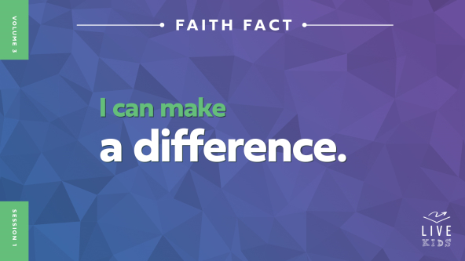

I don’t want anyone to forget today’s Faith Fact! So stand up, and let’s get going again. We’re going to march in place while saying the Faith Fact: **I can make a difference.** Boys, shout out the Faith Fact while you’re marching. **I can make a difference.** Girls, shout out the Faith Fact while you’re marching. **I can make a difference.** Now everyone, shout out the Faith Fact. **I can make a difference.** Great job! We can each make a difference on our own. But just imagine what we can do together.

**Game**

**Head, Shoulders, Knees, or Toes?**

As we follow Jesus, we should act differently and live differently from people who don’t know Jesus. We can’t make a difference without being different. Our thoughts, words, and actions should show others we love Jesus.

Let’s play a game about being different. Who’s heard the song, “Head, Shoulders, Knees, and Toes”? *(Group response)* Great! Those are the four actions to choose from: touch your head, touch your shoulders, touch your knees, or touch your toes. Let’s practice those actions together before we play.

• *Practice touching your head, shoulders, knees, and toes a few times.*

• *Optional: Choose a kid to lead, so you can watch the group.*

I think you’re ready to play! For each round, I’ll close my eyes so I can’t see you. I’ll count to three slowly. You will each do one of the four actions and freeze in place when I say, “Three.” When I say, “Go,” I’ll do an action and open my eyes. Anyone who matches my action is out of the game and must sit down.

• *Optional: Let kids take turns leading the rounds.*

• *Keep playing until only one kid is left in the game.*

Congratulations to the winner! Remember, we can’t expect to make a difference in the world if we act just like people who don’t know Jesus. We are meant to make a difference just like our Faith Fact says. Say it with me. **I can make a difference.**

**Worship**

Worshipping Jesus changes us. And it also shows how different we are. When other people see us worshipping Jesus, they will see how good He is. And maybe they’ll want to serve Him too! Let’s worship Him through our singing right now.

• *Lead the kids in singing one or two praise songs. See suggestions at the beginning of the session.*

**Bible Lesson**

Thanks for worshipping with me today. Your worship really does make a difference! Speaking of making a difference, I can’t think of a better example than the first disciples who followed Jesus. Can you imagine all the people who never would’ve heard about Jesus if the disciples decided not to follow Him? *(Group response)* They made a huge difference! Before we find out how Jesus called them to follow Him, let’s pray.

**Prayer**

|  |
| --- |
| *Dear Jesus, thanks for choosing disciples who showed us how we can live for You. We want to make a difference like they did. Help us let go of whatever You tell us to, so we can follow You like those first disciples. Amen.* |

**Video Intro**

Just before we look at the Bible story, let’s watch the Kids Bible Vlog.

• *Play* ***Bible Lesson Video.***

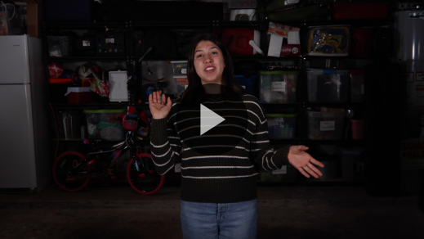

**Bible Story**

**The First Disciples Leave Everything**

What a great intro to our Bible story about Jesus’ first disciples! What kind of people could Jesus have called to become His first disciples? *(Allow responses.)* Jesus could have chosen anyone to follow Him. He could have chosen kings and queens, rich people, celebrities—anyone He wanted. But He chose some people you might not expect.

In today’s Bible story, we’ll see how Jesus called some fishermen to follow Him. What do you think the fishermen were good at doing? *(Group response)* They were probably great at fishing and sailing a boat. Do you think they were great at preaching or teaching when Jesus called them? *(Group response)* I don’t think so. But Jesus chose them anyway.

**Teaching Time**

|  |
| --- |
| ***You Will Need***  *• Calendar*  *• Red pen*  *•* ***Bible Story Teaching Time Slide***  ***Getting Ready***  *• Circle some dates on the calendar in red.*  *• Write some activities on the calendar: parties, practices, birthdays, etc.* |

I love reading the story of Jesus calling some of His first disciples: Simon (also called Peter), James, and John. They were just ordinary men doing ordinary jobs on an ordinary day. But when they met Jesus, their lives went from ordinary to extraordinary. Jesus can do the same thing for us if we let Him. Jesus can make the Faith Fact true for each of us. Say it with me. **I can make a difference.** Grab your Bible or pull up a Bible app on your device. Turn to [Luke 5:1–11](https://ref.ly/logosref/Bible.Lk5.1-11).

• *In order to keep Large Group time moving along, we recommend that the leader reads the Scripture portions aloud.*

• *Optional: Remind the kids to mark this place with a bookmark, so they can read it on their own at home.*

**1. Peter had a plan to get the job done.**

• *Show the* ***Teaching Point 1 Slide.***

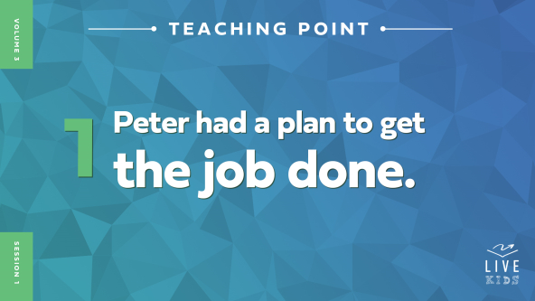

• *Read* [*Luke 5:1–5*](https://ref.ly/logosref/Bible.Lk5.1-5)*.*

Imagine being in the giant crowd of people gathered on the beach to hear Jesus. You could probably see Peter and the other fishermen working nearby. They’d been fishing all night and were cleaning their nets. How do you think Peter felt when Jesus borrowed his boat and started teaching? *(Allow responses.)*

Maybe Peter was curious because so many people were listening to Jesus. Or maybe he was tired and frustrated after working hard all night and catching nothing. Do you think Jesus was surprised by whatever Peter was feeling? *(Group response)* Not at all. Jesus knew Peter and the others still needed to catch some fish. So when Jesus finished teaching, He told them to take the boat into deeper water and let down their nets. Peter wasn’t too sure about Jesus’ plan. Peter had already tried to fish all night and nothing had happened.

• *Hold up a calendar and show the kids the dates that are circled.*

Do you know what this is? *(Group response)* That’s right, it’s a calendar. What is a calendar used for? *(Allow responses.)* Calendars help us plan our days, weeks, and months. They help us remember birthdays, appointments, practices, and parties. We try to plan out our life, but sometimes our plans don’t work out. Have you ever missed a party or practice because something else came up? (*Group response)*

I’m sure Peter hadn’t planned for Jesus to show up that day. The fishermen probably had planned to have a normal day of fishing and hard work. But Jesus changed their plans. In fact, He changed their lives! Do you think their day was better because Jesus showed up? *(Group response)* It was way better than they knew. Let’s find out why.

**2. Jesus gave Peter a mission.**

• *Show the* ***Teaching Point 2 Slide.***

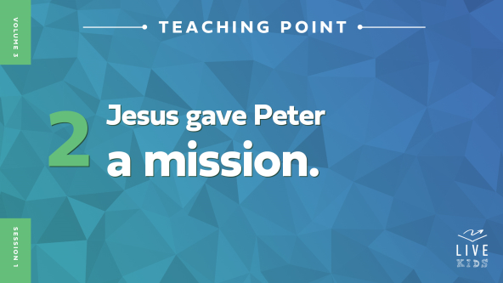

• *Read* [*Luke 5:6–10*](https://ref.ly/logosref/Bible.Lk5.6-10)*.*

Peter hadn’t caught any fish all night. So he probably didn’t think much would happen when he tried again in deeper water. Do you think Peter was surprised by what happened next? *(Group responses)* I think so! They caught so many fish that Peter’s boat almost sank!

• *Show the* ***Bible Story Teaching Time Slide****, a picture of a boat full of fish.*

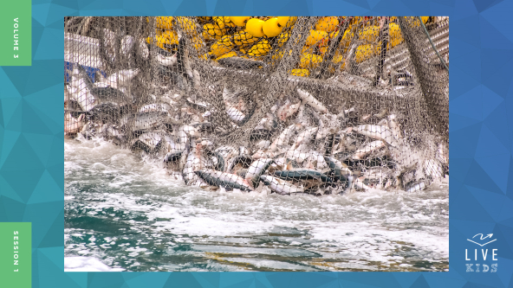

After Peter saw what happened, he knew that Jesus was a special person—totally different from everyone else. But what did Peter say to Jesus? *(Allow responses.)* Peter asked Jesus to leave! Peter didn’t think he deserved to be where Jesus was. But did Jesus leave? *(Group response)* No way! Jesus told Peter not to be afraid. Then He told Peter, James, and John to trade their ordinary jobs for a big, important mission. What was the mission Jesus gave them? *(Allow responses.)*

Jesus said Peter was about to start fishing for people instead of fish. Do you think Peter knew what that meant? *(Group response)* Probably not. Jesus was calling Peter, James, and John to be some of His first disciples. Jesus wanted them to follow Him and teach others about Him. Do you think that was a better job than being a fisherman? *(Allow responses.)* Peter, James, and John thought so too.

**3. The disciples left everything to follow Jesus.**

• *Show the* ***Teaching Point 3 Slide.***

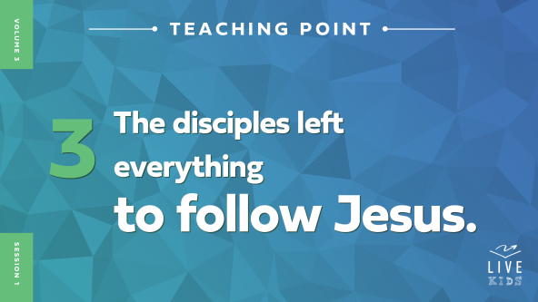

• *Read* [*Luke 5:11*](https://ref.ly/logosref/Bible.Lk5.11)*.*

The Bible doesn’t say exactly how Peter, James, and John felt when Jesus gave them this incredible mission. We only know what they did. Right away, they left the things they had and followed Jesus.

They knew Jesus’ mission was important. But do you think it was a hard choice for them to leave things behind? *(Group response)* Would it be hard for you leave your family, your friends, or your home to follow Jesus? *(Group response)* Talk about stepping out of your comfort zone!

What are some of the things and people you think the disciples had to leave? *(Allow responses.)* We may not know the details, but we do know they left things behind because Jesus was so much more important. Do you think they made the right decision? *(Group response)* They probably didn’t know it yet, but it was the best decision ever.

**Prayer and Response**

*Consider playing a worship song softly in the background while kids pray.*

Jesus is also calling each one of us to follow Him. Maybe we don’t have to let go of the kinds of things the first disciples did. But Jesus will probably tell us to step out of our comfort zone or give up something to follow Him.

Let’s pray for a few minutes. Ask Jesus if there is something you should let go of or leave behind so you can be part of His mission. Would you give up anything to follow Jesus?

• *Encourage kids to remain quiet and respectful as kids continue praying and listening for God to speak to them.*

**Prayer**

*Optional: Have the kids repeat phrases of the prayer after you.*

|  |
| --- |
| *Dear Jesus, thanks for letting me take on the mission You have for my life. Give me the courage to let go of anything so I can follow You. Amen.* |

**Faith Verse**

Our Faith Verse is so powerful. It reminds us that Jesus has always planned to call us and send us out to make a difference in this world. Let’s learn it together.

• *Play* ***Faith Verse Video.***

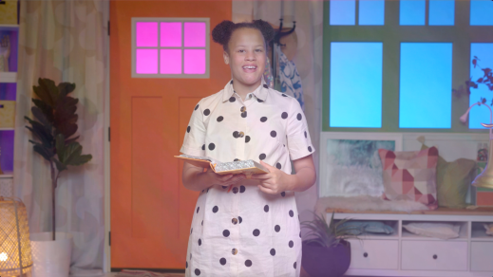

[John 20:21](https://ref.ly/logosref/Bible.Jn20.21)

[Jesus] said, “Peace be with you. As the Father has sent me, so I am sending you.”

Did you catch that? Jesus is sending us out in the same way God sent Him. We get to be part of His mission to tell others the good news of Jesus. That’s a huge deal!

**Faith Fact**

Before we move on, let’s say our Faith Fact again. **I can make a difference.**

• *Show the* ***Faith Fact Slide.***



Everyone, jump up and spin around while we say the Faith Fact one more time. **I can make a difference.** Do you believe that? *(Group response)* Say it louder as you jump and spin. **I can make a difference.** If you follow Jesus and do His mission, you will make a difference!

• *Dismiss kids to Small Group time or to go home if your group time ends here.*

**Small Group**

**30 Minutes**

*This section can be done in conjunction with the large group or on its own if you do small groups with your kids. During Small Group time, the goal is to connect the kids with the Word of God and to each other. All activities are led by the small group leader.*

**Group Connection**

**Let Go!**

|  |
| --- |
| *No prep is needed for this activity.* |

Are you good at letting go of things? For example, if you had to give your favorite toy away, would it be easy or hard? *(Allow responses.)*

• *Share your honest response to this question.*

Let’s find out how good you are at letting go. Everyone will be in pairs. At first, one partner will be in charge and make all the decisions. Then after one minute, you’ll switch and the other person will be in charge. When you’re in charge you can tell the other person what actions to do, but make sure you are kind and careful! Are you ready to play? *(Group response)*

• *Pair up the kids. It may be better for boys to be with boys and girls to pair with girls.*

• *Have the kids choose which partner will be in control first.*

• *If the kids are struggling with ideas of what to tell the other person to do, give them examples like doing a certain exercise, using a silly voice, sharing a fact about themselves, etc.*

Was it easier to be in charge or to let go? *(Allow responses.)* Lots of people like having control. It’s hard to let go and let someone else be in charge—especially when they tell you what to do. But choosing to follow Jesus and do His mission means letting go of control. It means letting Jesus be in charge. His mission is always better than our own plans.

**Bible Lesson Recap**

• *If small group activities are not immediately following large group time, you may want to read the Bible story passage before the discussion.*

|  |
| --- |
| ***You Will Need***  *• Bibles for kids in the group to share*  *No prep needed for this activity.* |

**Bible Story Review: The First Disciples Leave Everything** [**Luke 5:1–11**](https://ref.ly/logosref/Bible.Lk5.1-11)

We don’t know what Jesus preached about that day, but we know a huge crowd gathered to listen. There were so many people that Jesus had to get in Peter’s boat so they could all hear Him. Then Jesus told Peter to take the boat to the deeper water and try fishing again. This time they caught so many fish that the boat almost sank!

Peter, James, and John were amazed. They knew Jesus had performed a miracle for them. But Jesus did so much more than provide a bunch of fish. He gave them a mission. It was time to fish for people instead of fish. Right away, Peter, James, and John left everything to follow Jesus. They knew Jesus’ mission mattered more than anything else.

• *Optional: Give each kid a Bible and read the Bible story together.*

**Group Discussion**

*Feel free to use all or just a few questions as a jumping-off place for good discussion. Questions marked with * are designed for more conversation. Adjust the questions based on the age or maturity of your group. Typically, older kids will be able to dive a little deeper than younger ones.*

**Questions**

Who were Jesus’ three disciples listed in this story?

* Use your imagination to describe what a day in Peter’s life would have been like before he met Jesus.

* Why do you think Jesus performed a miracle for Peter and the other fishermen?

What did Jesus say Peter, James, and John would be fishing for if they followed Him?

* What do you think was the hardest thing for the disciples to leave behind so they could follow Jesus?

How do you imagine the disciples’ families and friends reacted when they began following Jesus?

* How did the disciples’ lives change after they met Jesus?

* What is something Jesus might tell you to let go of so you can follow Him and do His mission?

* How can Jesus help you make a difference in people’s lives?

**Live It**

|  |
| --- |
| *No prep is needed for this activity.* |

**Faith Fact**

Our Faith Fact today is **I can make a difference.** Say that with me one more time. **I can make a difference.** How did Jesus make a difference in the fishermen’s lives? *(Allow responses.)* He completely changed their lives! Countless people would come to know Jesus because those disciples decided to follow Him. We can make a difference for Jesus too, but only when we let go of our plans and our way to follow Him.

**Challenge**

What is something you can let go of so you can follow Jesus better? Maybe you could let go of playing video games or watching videos and spend some of that time with Jesus. Maybe you could let go of your fear and ask a friend to come to church with you. Choose something to let go of this week. It will make a difference in your life and someone else’s life.

**Prayer**

*Finish group discussion by sharing prayer requests and praise reports. Keep track of your small group’s prayer requests and review them each time you meet.*

• *Have kids share and pray for each other’s prayer requests.*

|  |
| --- |
| *Dear Jesus, help us see what we need to let go of. We want to serve You better and make a difference in the world. Amen*. |

**Faith Verse Review**

|  |
| --- |
| ***You Will Need***  *• Fish crackers, at least five per kid*  *• Cups, one per kid*  *• Pitcher of water*  ***Getting Ready***  *• Pour a cup of water for each kid.* |

Our Faith Verse is [John 20:21](https://ref.ly/logosref/Bible.Jn20.21). This verse reminds us we don’t need to be afraid because Jesus is with us. And just like God sent Jesus on a special mission, Jesus is sending us.

• *Show* ***Faith Verse Video.***



[John 20:21](https://ref.ly/logosref/Bible.Jn20.21)

[Jesus] said, “Peace be with you. As the Father has sent me, so I am sending you.”

Let’s practice our Faith Verse, so we’re ready for a fun, fishy challenge.

• *Say the verse as a group a couple of times.*

**Faith Verse Fun**

**Fishy Faith Verse**

We’re going to have some fishy fun while learning our Faith Verse today. I will give each of you some fish crackers. Don’t eat them just yet! We’re going to say the Faith Verse together, but each time we’ll add one more fish cracker to our mouths. Let’s see if we can say the Faith Verse together five times with our “fishy” mouths!

• *Give each kid five fish crackers.*

• *Say the Faith Verse with the kids. Each time you say it, tell the kids to add one more fish cracker to their mouths.*

• *Keep saying the Faith Verse until you reach the goal.*

• *Pause for the kids to finish the crackers and water.*

That was a lot of fun! And it was tasty too! You know, if you take some time to memorize this Faith Verse at home, it’ll remind you to stay ready to do Jesus’ mission.

**Activity Page**

**Finish the Picture**

|  |
| --- |
| ***You Will Need***  *•* ***Small Group Activity Page****, one per kid*  *• Pencils or pens, one per kid*  *• Crayons or markers*  ***Getting Ready***  *• Print copies of the* ***Small Group Activity Page****, one per kid.* |

The picture on this page shows Peter and another fisherman in the boat as he was catching all the fish. But part of the boat is missing. Can you finish the picture by mirroring the art on the other side?

• *Give each kid a copy of the* ***Small Group Activity Page*** *and a pencil or pen.*

• *Let them finish the picture.*

This picture is a great reminder of Jesus calling the disciples to start fishing for people. Jesus wants us to tell people about Him too. In the two big fish, write the names of two people you know who need to follow Jesus.

• *Give kids a few moments to choose whose names to write.*

• *Talk with them individually about who they chose.*

What are some ways you can help someone know more about Jesus? *(Allow responses.)* The next step is to pray and ask Jesus to show you what to say and do. You can make a difference that person’s life.

**Dismissal**

It’s been a lot of fun learning about Jesus calling some of His first disciples. It’s awesome that they were willing to let go and leave things behind to follow Jesus and do His mission. Jesus has a mission for all of us. We are all called to go out and make a difference in the world. Let’s pray and ask Jesus to help us make a difference starting right now.

**Prayer**

|  |
| --- |
| *Dear Jesus, thank You for calling us to let go and follow Your mission. Help us to start making a difference in our world right now. Amen.* |

**Faith Fact Recap**

• *Show the* ***Faith Fact Slide.***



Who can tell me today’s Faith Fact? *(Allow responses.)* That’s right! **I can make a difference.** Now go and make a difference in your family, your school, and your neighborhood! I can’t wait to see you next time as we find out more about Jesus’ mission for us.

• *Send home the* ***Small Group Activity Page.***

• *Remind parents that there are* ***Family Devotions*** *available on the app to do with their kid.*

• *Tell everyone the date and time for the next session.*